The work has to be delivered by 14 September 2020
- You will find three scenarios (R, C and B) and you have to face the problems using: HOTSPOT, WISER/ALOHA and STEM.
- The final output is a tech report.
- The final report is expected to be between 7.000 – 14.000 words excluding tables and images
- Bear in mind that for the tech report you have the lecture of Dr. Quaranta at the beginning of the module. DO NOT FORGET THE REFERENCES!

BIOLOGICAL SCENARIO
Scenario:
Analyze the diffusion of smallpox virus (starting from the region of Liguria-Italy) considering a number of index cases = 75 and a period from 1 January 2016 to 1 February 2016.

Suggestion:
- Use STEM software

CHEMICAL SCENARIO (same for both the TEAM blue and red)
- Scenario

It is the 25 of June 2016, at the end of Angelus of Pope Francis all people leave Saint Peter Square. The estimated number of people present on site is 500.000.
Your Team is on duty in at the Fire fighter operational center and the threat level for terrorist attack is very high for the Giubileo.
Italian Air Force meteo forecast:

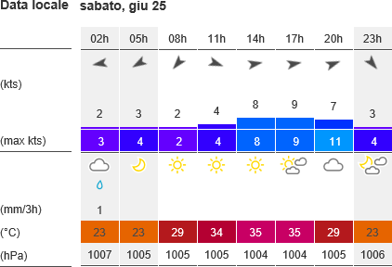

- Event
A police unit locates in Saint Peter Square informs the operational center about a strong chemical smell and many people falling down and many other have the following symptoms:
  - eye irritation
  - tearing
  - vision loss
  - nasal irritation
  - coughing/choking
  - drooling/salivation

- Release area additional information

A police unit repots a trailer located in Paolo VI Street with a tank that has leakage of chemical substance from a draining valve. To help the identification send the tank picture to the operational center.
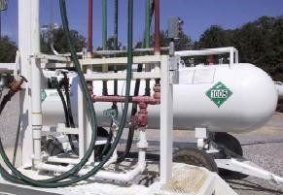
The police unit report also a communication received by the superior authority about a theft of a similar trailer from a chemical plant that produce Ammonia and Chlorine.
The CBRN Fire Fighter Unit report the meteo update on site as follow:
- Wind 280°- 2 m/s
- Temp 30°C
- Umidity 50%
- Cloud coverage completely cover 8/8
This unit also reports the first identification of the chemical substance with detector CHEM PRO 100 gives the indication that the chemical substance is Ammonia

Question 1
- Assess the situation with Wiser and ERG 2016 (Simplified prediction) Question 2
- Assess the situation with Wiser and ERG 2016 (Detailed prediction)

Question 3
- Assess the situation with Aloha (Enhanced prediction)
- Export the Enhanced prediction on Google Maps (also in 3D) Exercise Indication

You have to describe step by step all prediction phase and consequence management action necessary to manage the release area.
The Report will be dividing in:
- Scenario assessment
- Event description
- Simplified prediction
- Detailed prediction
- Enhanced prediction
- Describe consequence management action (ERG 2016)

RADIOLOGICAL SCENARIO
Scenario’s accident: FUKUSHIMA
Design the scenario (working with proper references you can find on the net), once you have a scenario you have to:
- Choose the proper boundary conditions (height of release point, type of radiological substances involved, meteorological conditions);
- Implement the simulations
- Compare the numerical data with the measured one that you can find in the official report and paper of the accident (see the folder scenario inside each accident folder to begin this work)
- Once the comparison match you have to geo-reference the contamination map produced by HOT-SPOT on a 2D geographical map.
Once you have done this work you have to:
- Discuss about the actions of a First Responders in that scenario.

